horizontal line

EE208:CONTROL ENGINEERING LAB 02

# Controller design on MATLAB platform using Analog Root Loci

## 

## Course Instructor : Dr. Sanjay Roy

## Date : 21st January 2022



## Group Number - 14

## 

## Raj Kumar Deb 2020eeb1025

## Tushar Sharma 2020eeb1325

## Tiya Jain 2020eeb1213

# TABLE OF CONTENTS

**TABLE OF CONTENTS** **2**

**1. OBJECTIVE** **3**

**2. GIVEN** **3**

**3. THEORY** **3**

3.1 Closed Loop Transfer Function 3

3.1.1 Block Diagram 4

3.1.2 Transfer Function 4

3.3 Sensitivity of a closed loop system 5

**4. OBSERVATIONS** **5**

4.1 Variation in value of T 5

4.2 Routh-Hurwitz Stability Criteria 7

4.3 Using Gain Parameter 9

**5. ANALYSIS** **13**

5.1 Interpretation and Effect of Poles on Root Loci 13

5.2 Trade off between Settling Time, Overshoot, Peak Time and Damping Ratio 14

5.3 Interpretation of Step Responses in terms of Poles 15

5.4 Sensitivity of CLTF w.r.t. parameters 15

5.4.1 Sensitivity of GCL(s) wrt A 16

5.4.2 Sensitivity of GCL(s) wrt B 16

5.4.3 Sensitivity of GCL(s) wrt K 16

**6. CONCLUSION** **17**

**7. MATLAB SCRIPTS** **17**

# 

# 

# 1. OBJECTIVE

To design state feedback for a given digital state-space system, so as to realize performance specifications for different applications.

# 2. GIVEN

The fourth order analog OLTF is to be operated on a closed loop with a choice of T such that the complex poles have a damping ratio of 0.2 to 0.25. The value of T is to be selected so as to realize the required damping ratio regardless of parameter variations which are prone to 土20% deviation from the original values.

| **GOL(s) =** |
| --- |

# 3. THEORY

### 3.1 Closed Loop Transfer Function

#### **3.1.1 Block Diagram**



**Figure 3.1.1 Block diagram for the CLTF of the given system**

#### **3.1.2 Transfer Function**

The CLTF is written using the formula :

| = |
| --- |

**3.2 Types of damping:**

1. **Undamped system** – There is no damping in case of an undamped system, and hence the oscillations in the response do not tend to die out. In this case, **ζ = 0.**
2. **Under-damped system** – The magnitude of oscillations keeps reducing with the passage of time due to damping, and hence approaches a steady state value. This kind of oscillatory response is a favorable one for a better control design. In this case, **0 < ζ < 1**. Thus, the required condition for the particular problem (damping ratio between **0.2 to 0.25**) is the case of an **under-damped system**.
3. **Critically damped system** – In this case, the damping ratio is one (**ζ = 1**). The response moves towards its equilibrium value directly rather than oscillating for long. The response is rather a lag-type response.
4. **Over-damped system** – In this case, **ζ > 1**. The response is of lag-type in this case also, reaches to a steady value without oscillating.

### 

### 3.3 Sensitivity of a closed loop system

The parameters of a control system keeps changing due to various reasons like surrounding conditions or internal disturbances. Sensitivity of a transfer function is a measure of the change in system response with respect to the change in input or any other parameter of the system.

For a good control design system it is expected that –

1. The system is **more sensitive** to any **change in input**, so that the system responds smoothly and the desired change in output can occur with minimum effort once the input is changed.
2. The system should be **less sensitive** to **parameter changes** due to disturbances, so that the performance of the system is not affected significantly due to arbitrary disturbances in the environment.
3. The **sensitivity** of a system is mainly studied with respect to **parameter variations** in control systems and hence the major motive is to **reduce the sensitivity** in that case.
4. The **Sensitivity** for a closed loop transfer function is **reduced** by a factor of 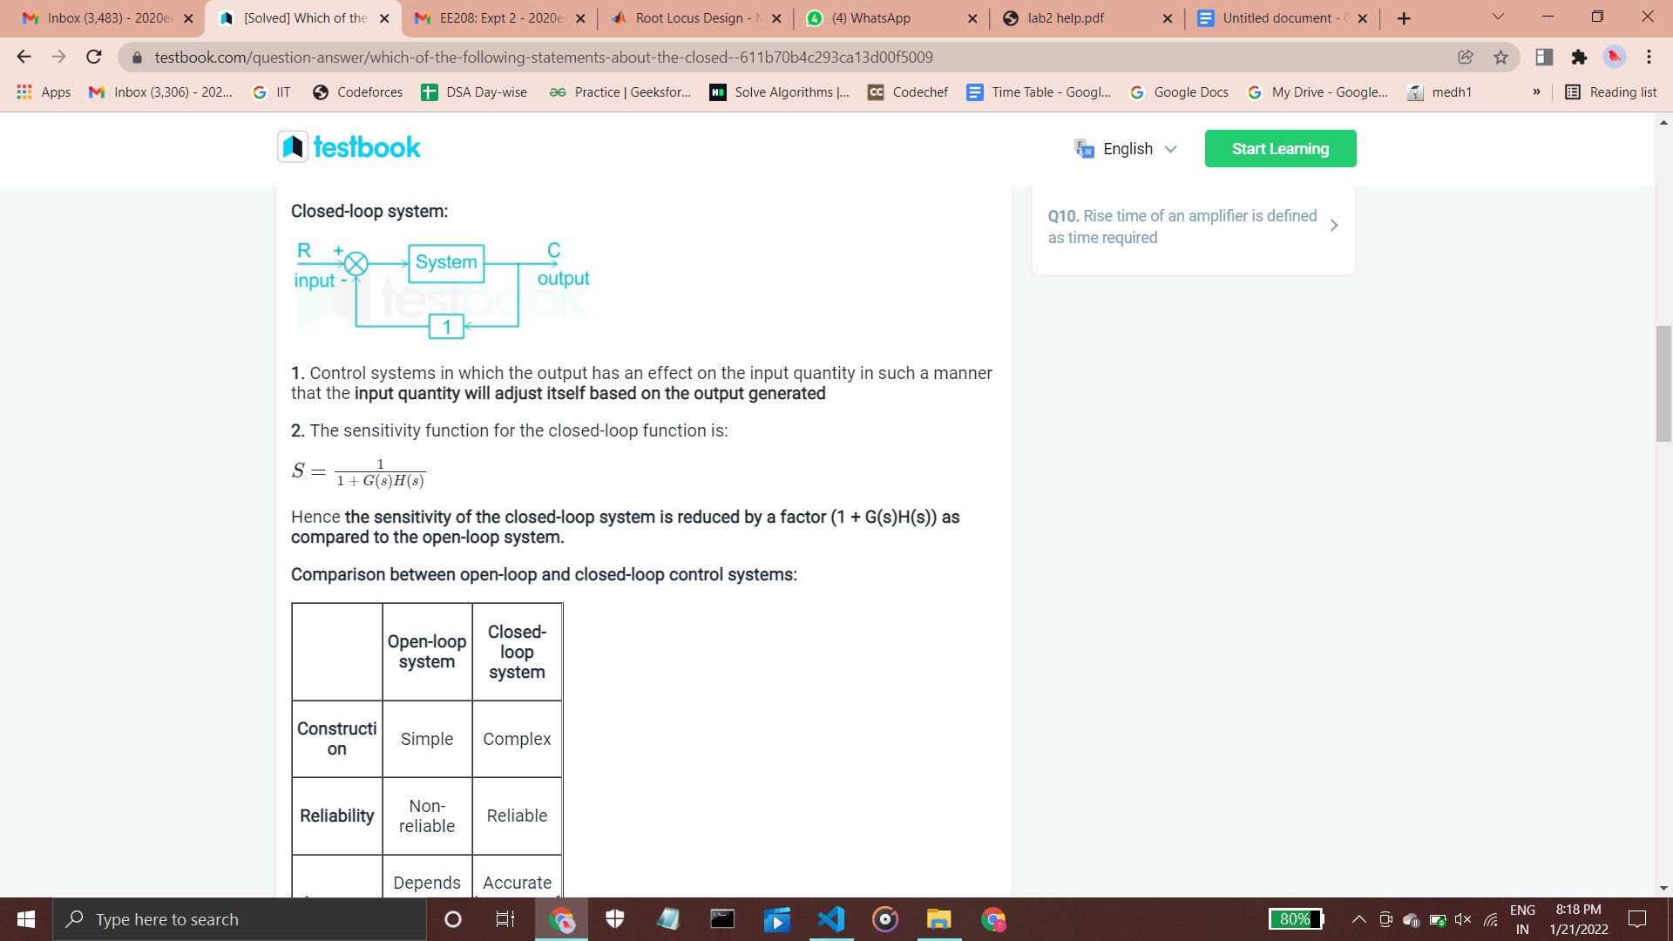

as compared to its open loop counterpart.

# 

# 4. OBSERVATIONS

### 4.1 Variation in value of T

| | **T** | **Damping Ratio (𝛇)** | | --- | --- | | -1000 | -1.00 | | -500 | -1.00 | | -250 | -1.00 | | 0 | -0.11 | | 100 | -0.07 | | 250 | -0.04 | | 500 | -0.03 | | 1000 | -0.02 | | | **T** | **Damping Ratio (𝛇)** | | --- | --- | | -0.2 | -1.00 | | -0.16 | -1.00 | | -0.08 | -1.00 | | 0 | -0.11 | | 0.04 | -0.21 | | 0.1 | -0.28 | | 0.16 | -0.30 | | 0.2 | -0.31 | |
| --- | --- | --- | --- | --- | --- | --- | --- | --- | --- | --- | --- | --- | --- | --- | --- | --- | --- | --- | --- | --- | --- | --- | --- | --- | --- | --- | --- | --- | --- | --- | --- | --- | --- | --- | --- | --- | --- |

**Figure 4.1.1 Parameter ‘T’ Vs Damping Ratio**

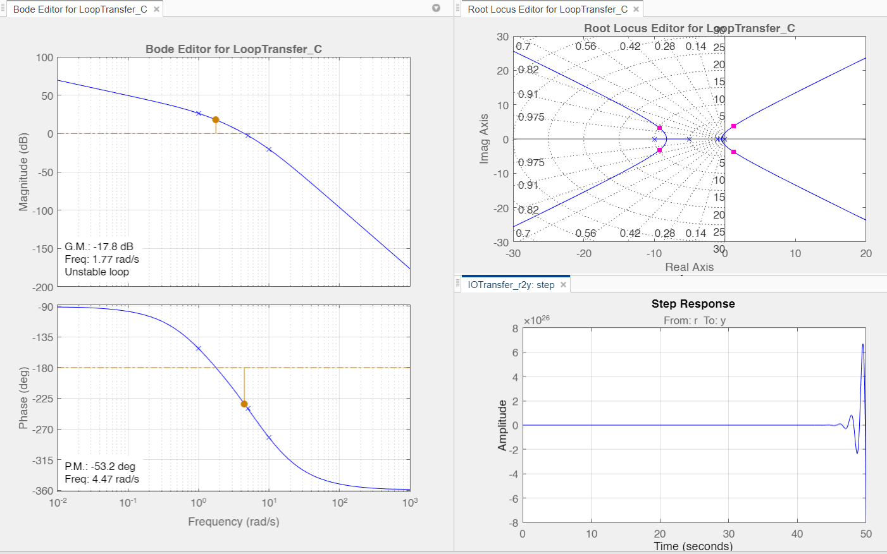

**Figure 4.1.2 Instability of the given Transfer Function**

* For a wide range of parameter ‘T’ (ie. T) we observe a negative damping ratio which indicates that the system is gaining energy from an outer source which is totally an unwanted case.
* Likewise few poles of the system have positive real value which indicates that the whole system is unstable.
* A further analysis of the step response indicates that the response starts fluctuating after approximately 45 seconds and hence goes unstable, which is not expected and hence the given system is not desirable.

### 4.2 Routh-Hurwitz Stability Criteria

After analyzing the root loci plots our next step was to perform stability analysis for this system.We chose R-H Stability criteria to easily determine the stability of the system.

For checking the R-H Criteria we first need to calculate the characteristic equation which comes out to be:

| **4.2.1 The characteristic equation** |
| --- |

Now plotting the R-H Array Table we get:

|  | 0.02T | 0.3+T | 30 |
| --- | --- | --- | --- |
|  | 0.3T+0.02 | 1 | 0 |
|  |  | 30 | 0 |
|  |  | 0 | 0 |
|  | 30 |  | 0 |

**4.2.2 The Routh- Hurwitz Array**

The necessary condition is that all the elements of the first column of the Routh array should have the same sign. This means that all the elements of the first column of the Routh array should be either positive or negative. But in this case, the condition can never be satisfied.

**Case 1 (T > 0)** : In the routh array, the 1st column elements corresponding to , are positive but that of has the opposite sign. Hence, the R-H condition is not satisfied.

**Case 2 (T < 0)** : The sign of coefficients of all the powers of s in the characteristic equation should be the same, which is a necessary condition for stability of any system. But for any value of T< 0, the condition is violated and hence the given system is unstable.

**This leads to one of our conclusions that the system is unstable for any value of T.**

We observe that the negative sign in the first column element corresponding to is due to the large value of 30 in the numerator.

To overcome this situation, we had to modify our system using PID .So, the simplest approach that we came up with was to add a compensator in order to reduce the overall value of gain. Again by the RH method, we can also determine the range of K for stability and the point of intersection for the root locus with the imaginary axis.

**4.2.3 The block diagram with a compensator gain K**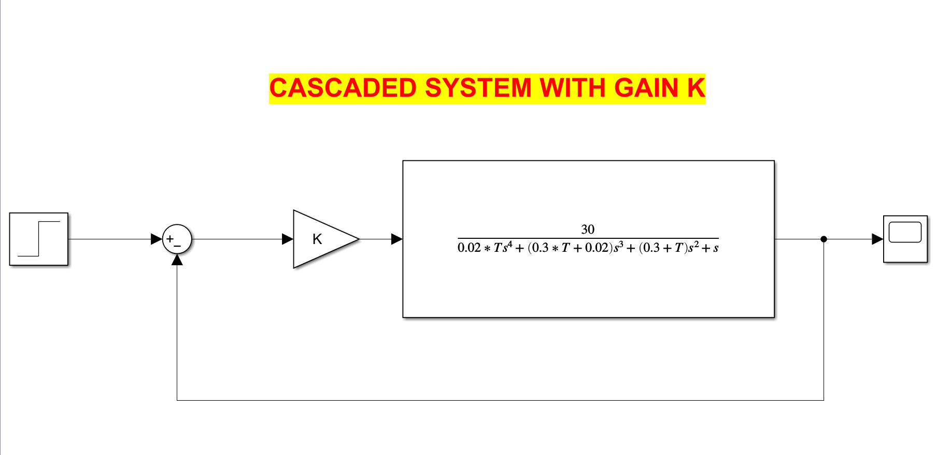

Taking a case in consideration for T=1, we get the range for value of 0 K 0.1289. Therefore our system is conditionally stable and beyond this interval (ie K) for the value of T=1 the system becomes unstable.

### 

### 4.3 Using Gain Parameter

## Gain Parameter K = 1/300 & T = 3

# 

## Gain Parameter K = 1.37/30 & T = 1

# 

Using a Gain parameter, we were able to obtain a stable system. Further we tried to examine the variations in Gain ‘K’ and the parameter ‘T’ to find a suitable range or value of K & T.

| | **T = 1** | | | | | | --- | --- | --- | --- | --- | | **K** | **Overshoot** | **Peak Time** | **Settling Time** | **Damping Ratio** | | 0.045 | 42.48 | 3.2637 | 12.98 | 0.255 | | 0.046 | 43.37 | 3.1461 | 12.9 | 0.249 | | 0.047 | 44.28 | 3.1928 | 12.8 | 0.243 | | 0.048 | 45.12 | 3.0701 | 14.75 | 0.237 | | 0.049 | 46.04 | 3.1165 | 14.79 | 0.231 | | 0.05 | 46.77 | 2.9882 | 14.77 | 0.225 | | 0.051 | 47.79 | 3.0343 | 14.72 | 0.22 | | 0.052 | 48.63 | 3.0002 | 14.65 | 0.215 | | 0.053 | 49.46 | 2.9778 | 14.58 | 0.21 | | 0.054 | 50.28 | 2.9555 | 14.5 | 0.205 | | 0.055 | 51.09 | 2.9334 | 16.36 | 0.2 |   **K Є (0.045,0.055) at T = 1** | | **T = 2** | | | | | | --- | --- | --- | --- | --- | | **K** | **Overshoot** | **Peak Time** | **Settling Time** | **Damping Ratio** | | 0.045 | 54.88 | 4.12 | 25.32 | 0.181 | | 0.046 | 56.07 | 4.19 | 25.14 | 0.176 | | 0.047 | 56.82 | 4.25 | 27.94 | 0.172 | | 0.048 | 57.19 | 3.98 | 27.93 | 0.168 | | 0.049 | 58.41 | 4.04 | 27.81 | 0.163 | | 0.05 | 59.2 | 4.11 | 27.66 | 0.159 | | 0.051 | 59.51 | 4.17 | 27.5 | 0.155 | | 0.052 | 60.53 | 3.89 | 30.18 | 0.151 | | 0.053 | 61.48 | 3.95 | 30.2 | 0.148 | | 0.054 | 62.19 | 3.94 | 30.09 | 0.144 | | 0.055 | 62.9 | 3.91 | 29.95 | 0.14 |   **K Є (0.045,0.045) at T = 2** |
| --- | --- | --- | --- | --- | --- | --- | --- | --- | --- | --- | --- | --- | --- | --- | --- | --- | --- | --- | --- | --- | --- | --- | --- | --- | --- | --- | --- | --- | --- | --- | --- | --- | --- | --- | --- | --- | --- | --- | --- | --- | --- | --- | --- | --- | --- | --- | --- | --- | --- | --- | --- | --- | --- | --- | --- | --- | --- | --- | --- | --- | --- | --- | --- | --- | --- | --- | --- | --- | --- | --- | --- | --- | --- | --- | --- | --- | --- | --- | --- | --- | --- | --- | --- | --- | --- | --- | --- | --- | --- | --- | --- | --- | --- | --- | --- | --- | --- | --- | --- | --- | --- | --- | --- | --- | --- | --- | --- | --- | --- | --- | --- | --- | --- | --- | --- | --- | --- | --- | --- | --- | --- | --- | --- | --- | --- | --- | --- | --- | --- | --- | --- |
| | **T = 0.5** | | | | | | --- | --- | --- | --- | --- | | **K** | **Overshoot** | **Peak Time** | **Settling Time** | **Damping Ratio** | | 0.045 | 28.87 | 2.54 | 7.56 | 0.357 | | 0.046 | 29.79 | 2.5 | 7.55 | 0.348 | | 0.047 | 30.7 | 2.47 | 7.53 | 0.34 | | 0.048 | 31.6 | 2.45 | 7.5 | 0.332 | | 0.049 | 32.49 | 2.42 | 7.46 | 0.325 | | 0.05 | 33.37 | 2.39 | 7.42 | 0.317 | | 0.051 | 34.25 | 2.36 | 7.37 | 0.31 | | 0.052 | 35.11 | 2.34 | 7.33 | 0.303 | | 0.053 | 35.97 | 2.33 | 7.28 | 0.296 | | 0.054 | 36.82 | 2.31 | 8.63 | 0.29 | | 0.055 | 37.67 | 2.28 | 8.68 | 0.283 |   **K Є (0.045,0.055) at T = 0.5** | | **T = 1** | | | | | | --- | --- | --- | --- | --- | | **K** | **Overshoot** | **Peak Time** | **Settling Time** | **Damping Ratio** | | 0.055 | 51.09 | 2.93 | 16.36 | 0.2 | | 0.056 | 51.89 | 2.89 | 16.41 | 0.195 | | 0.057 | 52.69 | 2.87 | 16.39 | 0.19 | | 0.058 | 53.47 | 2.85 | 16.35 | 0.186 | | 0.059 | 54.25 | 2.82 | 16.28 | 0.181 | | 0.06 | 55.02 | 2.8 | 16.21 | 0.177 | | 0.061 | 55.77 | 2.78 | 18.01 | 0.173 | | 0.062 | 56.52 | 2.76 | 18.07 | 0.168 | | 0.063 | 57.27 | 2.74 | 18.06 | 0.164 | | 0.064 | 58 | 2.72 | 18.01 | 0.16 | | 0.065 | 58.73 | 2.7 | 17.95 | 0.156 |   **K Є (0.055,0.065) at T = 1** |
| | **T = 1** | | | | | | --- | --- | --- | --- | --- | | **K** | **Overshoot** | **Peak Time** | **Settling Time** | **Damping Ratio** | | 0.035 | 32.67 | 3.68 | 11.56 | 0.329 | | 0.036 | 33.72 | 3.59 | 11.45 | 0.321 | | 0.037 | 34.69 | 3.49 | 11.34 | 0.312 | | 0.038 | 35.77 | 3.54 | 11.23 | 0.304 | | 0.039 | 36.78 | 3.44 | 11.12 | 0.297 | | 0.04 | 37.67 | 3.49 | 13.23 | 0.289 | | 0.041 | 38.75 | 3.39 | 13.24 | 0.282 | | 0.042 | 39.64 | 3.28 | 13.2 | 0.275 | | 0.043 | 40.64 | 3.32 | 13.14 | 0.268 | | 0.044 | 41.55 | 3.21 | 13.07 | 0.261 | | 0.045 | 42.48 | 3.26 | 12.98 | 0.255 |   **K Є (0.035,0.045) at T = 1** | | **DAMPING RATIO (𝛇)** | | **VALUE OF GAIN ‘K’** | | | | | --- | --- | --- | --- | --- | --- | | **0.035** | **0.040** | **0.045** | **0.055** | |  | **-20** | -1.00 | -1.00 | -1.00 | -1.00 | | **-10** | -1.00 | -1.00 | -1.00 | -1.00 | | **-5** | -1.00 | -1.00 | -1.00 | -1.00 | | **0** | 0.947 | 0.869 | 0.804 | 0.701 | | **2** | 0.235 | 0.206 | 0.181 | 0.140 | | **5** | 0.149 | 0.130 | 0.114 | 0.088 | | **10** | 0.106 | 0.092 | 0.081 | 0.062 | | **20** | 0.074 | 0.065 | 0.057 | 0.044 |   **K Є (0.035,0.055) & T Є (-20,20)** |

* We interestingly observe that *Peak Time, Overshoot and Settling time* of step response have a Direct Relationship with the parameter ‘T’ and Inverse Relationship with the Damping Ratio.
* Clearly K also has an inverse relationship with damping ratio. From the heat map, we can observe that for **T Є (0,2) and K Є (0.035,0.055) will be an Ideal condition** to achieve the Damping Ratio (𝛇) in range of (0.20,0.25).
* Further we can observe from Root-Locus that with an increase in Gain parameter the system will move toward instability, so the *value of* *K cannot be larger than a certain point for any given value of T*. One such value of K is 0.127 for T = 1.

| **4.3.1 Variation in value of Pole 1 (-10) at K = 0.05**   | **% Change in Pole** | **Damping Ratio** | **Peak Time** | **Overshoot** | **Settling Time** | | --- | --- | --- | --- | --- | | -20 | 0.237 | 2.99 | 45.16 | 14.38 | | -10 | 0.231 | 3.07 | 46.05 | 14.61 | | -5 | 0.228 | 3.12 | 46.38 | 14.69 | | 0 | 0.225 | 2.98 | 46.77 | 14.77 | | 2 | 0.254 | 3.06 | 47.11 | 14.80 | | 5 | 0.223 | 3.07 | 47.37 | 14.84 | | 10 | 0.220 | 3.07 | 47.80 | 14.90 | | 20 | 0.214 | 3.08 | 48.65 | 15.02 | | **4.3.2 Variation in value of Pole 2 (-5) at K = 0.05**   | **% Change in Pole** | **Damping Ratio** | **Peak Time** | **Overshoot** | **Settling Time** | | --- | --- | --- | --- | --- | | -20 | 0.247 | 3.00 | 43.84 | 12.24 | | -10 | 0.236 | 2.99 | 45.36 | 14.40 | | -5 | 0.231 | 3.08 | 46.14 | 14.61 | | 0 | 0.225 | 2.98 | 46.77 | 14.77 | | 2 | 0.223 | 3.02 | 47.17 | 14.82 | | 5 | 0.220 | 3.06 | 47.70 | 14.90 | | 10 | 0.215 | 3.08 | 48.45 | 15.03 | | 20 | 0.205 | 3.11 | 49.93 | 15.24 | |
| --- | --- | --- | --- | --- | --- | --- | --- | --- | --- | --- | --- | --- | --- | --- | --- | --- | --- | --- | --- | --- | --- | --- | --- | --- | --- | --- | --- | --- | --- | --- | --- | --- | --- | --- | --- | --- | --- | --- | --- | --- | --- | --- | --- | --- | --- | --- | --- | --- | --- | --- | --- | --- | --- | --- | --- | --- | --- | --- | --- | --- | --- | --- | --- | --- | --- | --- | --- | --- | --- | --- | --- | --- | --- | --- | --- | --- | --- | --- | --- | --- | --- | --- | --- | --- | --- | --- | --- | --- | --- | --- | --- |

* The variations in the system parameters of the transfer function are **smooth and minimal** such that they don’t cross the range of provided damping ratio (of 0.2 to 0.25).
* The transfer function is robust i.e. the system parameters **don’t deviate significantly** with considerable variations in the poles. The desired *damping ratio can be maintained* even if the parameters of the denominator polynomial is **prone to 土20%** **variation** from the original values.

# 5. ANALYSIS

### 5.1 Interpretation and Effect of Poles on Root Loci

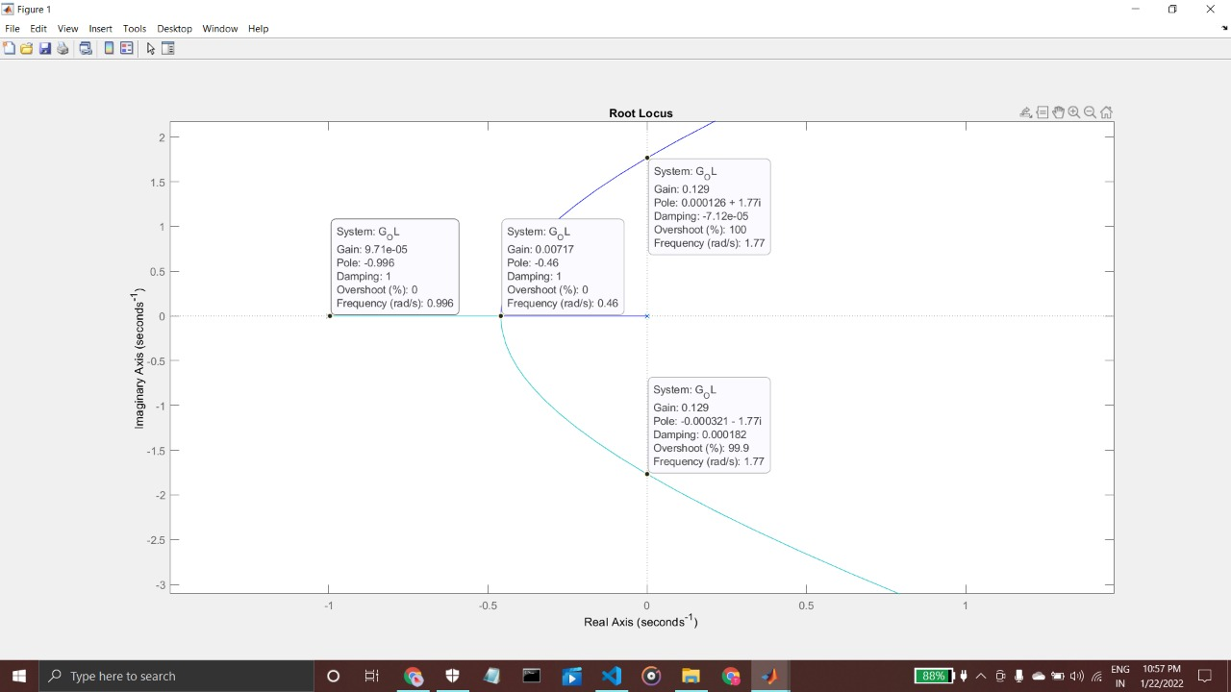

**Figure 5.1.1 Zoomed Root Loci**

**5.1.1** In a system with variable loop gain we observed that the location of closed loop poles depends on the value of gain chosen. For the given system, reducing the value of gain shifts the closed loop poles towards the left hand side and hence towards stability.

**5.1.2** According to the problem statement the damping ratio should be between the constant lines of damping ratio 0.2 and 0.25 which narrows our choice of desired poles. In order to drag the closed loop poles from their original locations to these expected range, the transfer function needs to be significantly modified, and it is further observed that the value of compensator gain for the purpose reduces from 1 (no additional gain or parameter) to approximately having a compensator value in the range of about 0.0457 to 0.055.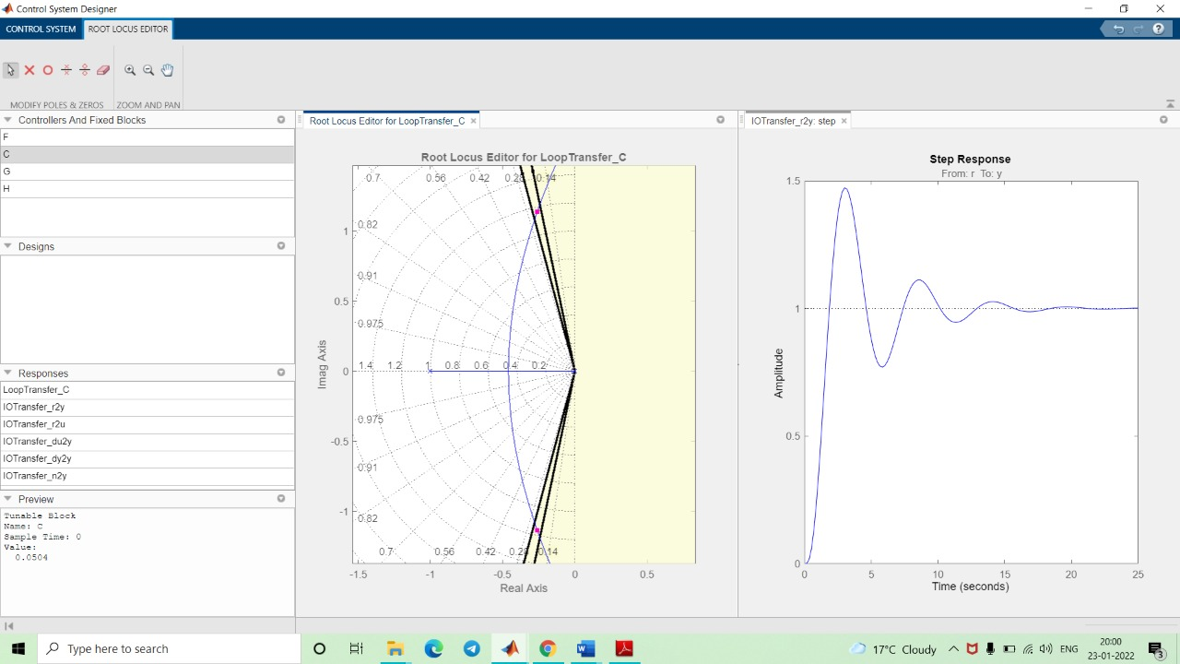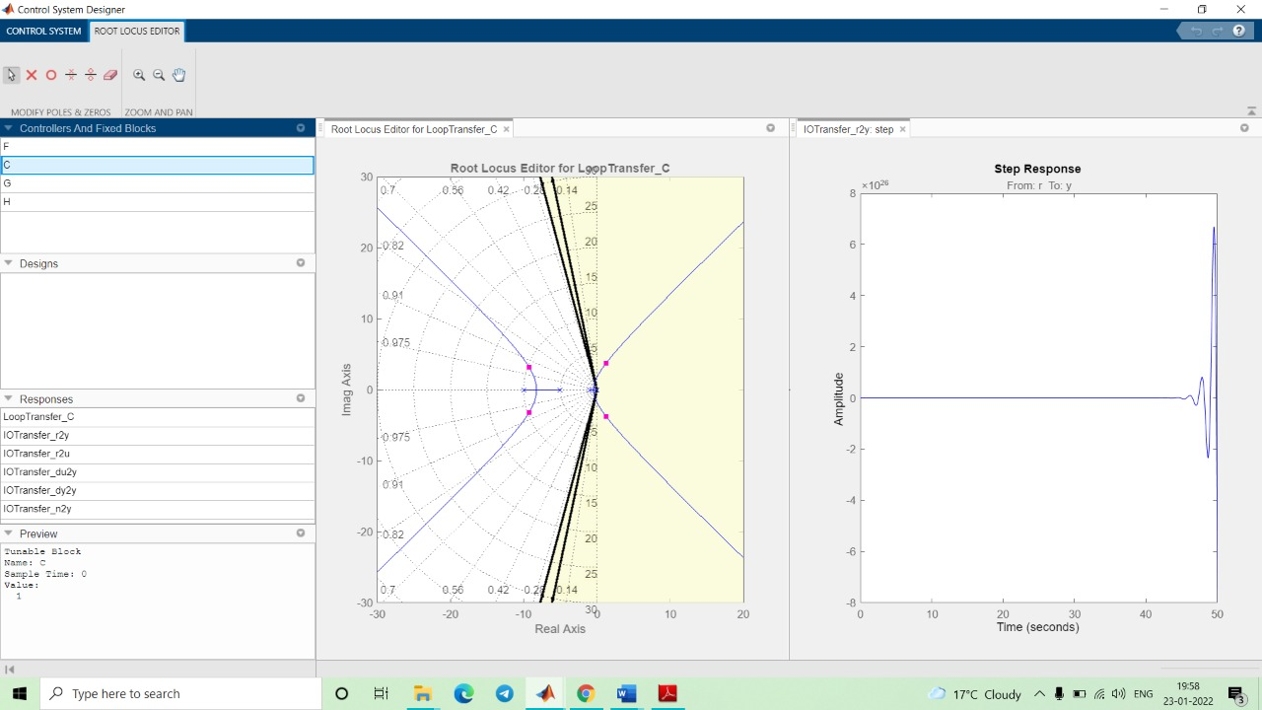

Fig 5.1.2 a) Root Loci and step response for Fig 5.1.2 b) Root Loci and step response when

given transfer function without modification the compensator gain is reduced to approx 0.05

**5.1.3 Effects of Adding Open Loop Poles on Root Locus :** The root locus can be shifted in ‘s’ plane by adding the open loop poles . If we include a pole in the open loop transfer function, then some of the root locus branches will move towards the right half of the ‘s’ plane. Because of this, the damping ratio ζ decreases. Which implies, damped frequency increases and the time domain specifications like delay time td, rise time tr and peak time tp decrease. But, it affects the system stability.

### 5.2 Trade off between Settling Time, Overshoot, Peak Time , Rise Time and Damping Ratio

| **OVERSHOOT** | **PEAK TIME** |
| --- | --- |
| **RISE TIME** | **SETTLING TIME** |

* Overshoot, Peak Time, Settling Time and Rise Time vary in the same order with both Gain ‘K’ and Parameter ‘T’. To obtain a lower overshoot and faster settling time we should choose lower values of K & T.
* *Contrary* to the evaluation of damping ratio, which stated to choose a certain range of values of Gain ‘K’ & T to maintain the damping ratio between 0.20 to 0.25.
* This shows that there is a **tradeoff** between the *Damping Ratio* and *Other System Parameters*.

### 5.3 Interpretation of Step Responses in terms of Poles

| **Step Response for T = 1 and K Є (0.035,0.055)** | **Step Response for T Є (5,10) and K = 0.045** |
| --- | --- |

* The variation in step response is greater when parameter T changes instead of K, both in terms of magnitude and time taken to observe the change.
* This is due to the parameter ‘T’ in terms of is a pole of the open loop, whereas the *Gain ‘K’* is not directly affecting the pole of the closed loop.

### 5.4 Sensitivity of CLTF w.r.t. parameters

In order to showcase the concept of sensitivity we find the differential form of sensitivity wrt to our two parameters : A = 0.1, B = 0.2 and K

#### **5.4.1 Sensitivity of wrt A**

|  |
| --- |

Observing closely we find that the value of *sensitivity tends to 1 for s =* . Considering T=1, K = 0.05 and an interval of the roots of the derivatives of the sensitivity function i.e. **s = 0, -0.61964, -6.18262, -4.24469**, we deduce that the sensitivity has a maximum value of **0.5592**.

#### **5.4.2 Sensitivity of wrt B**

|  |
| --- |

Observing closely we find that the value of *sensitivity tends to 1 for s =* . Considering T=1, K = 0.05 and an interval of the roots of the derivatives of the sensitivity function i.e. **s = 0, -14.39326**, we deduce that the sensitivity has a maximum value of **0.8211**.

#### **5.4.3 Sensitivity of wrt K**

|  |
| --- |

Observing closely we find that the value of *sensitivity tends to 1 for s =* . Considering T=1, K = 0.05 and an interval of the roots of the derivatives of the sensitivity function i.e. **s = -0.45963, -3.30049, -8.23986**, we deduce that the sensitivity has a maximum value of **0.6501**.

# 6. CONCLUSION

6.1 We plotted and examined the root loci of the given CLTF from which we concluded that the positions of roots were such that the system was **not stable** for **any value of T**.

6.2 Furthermore through the *Routh Hurwitz Stability Criteria* we found that our current system was unstable for any value of T (predominantly due to a **very large value of 30**) and therefore we added a **Compensator Gain**.

6.3 Varying the values of T and K we observed the general trends and tradeoffs in the system parameters such as *Damping Ratio, Settling Time , Peak Time, Overshoot*. We also compared the step responses in terms of poles.

6.4 Sensitivity Analysis was performed with respect to the parameters  **A=0.1 , B=0.2, K = 0.05 and T = 1**. We observed that for certain values of frequency, we were able to get low sensitivity. We also analyzed that the sensitivity reached 1 for *s* = .

6.5 Ultimately, the value of T is selected so as to comprehend the required damping ratio irrespective of the parameter variations, **T = 1** with value of **Compensator** **Gain K = 0.05**.

# 7. MATLAB SCRIPTS

|  |  |
| --- | --- |
|  |  |